Mission Statement
Our mission is to ensure that all children grow, believe and achieve. We provide a nurturing, inclusive and inspiring preschool environment where every child feels valued, supported and confident to reach their full potential.

Our Preschool Values
- Respect – We respect ourselves, others and the world around us.
- Kindness – We show care, empathy and compassion.
- Resilience – We learn to manage emotions, challenges and change.
- Excellence – We strive for high-quality learning and positive outcomes.
- Perseverance – We keep trying and develop confidence.
- Independence – We make choices and develop self-help skills.

Curriculum Intent
Our curriculum is designed to support children’s emotional wellbeing, positive relationships and connection with the natural world. Think Equal underpins our approach to emotional literacy, empathy and inclusion. The National Education Nature Park programme supports curiosity, environmental care and sustainability. Together they promote confidence, resilience and independence in line with the EYFS.

Curriculum Implementation
Learning is delivered through planned experiences, high-quality interactions and child-led play. Think Equal is embedded through stories, discussion, role play and modelling positive behaviour. The National Education Nature Park is implemented through outdoor learning, exploration, caring for plants and observing seasonal change.

Curriculum Impact
Children demonstrate emotional awareness, empathy and positive relationships. They show curiosity, respect for the natural world and confidence in learning. These experiences support readiness for the next stage of education.

Curriculum overview

Routine based on the EPPSE Project which found that the most effective settings are two thirds child initiated and one third adult initiated.
Effective Preschool, Primary school and Secondary education project (EPPSE 3-16+)
Taggart, B, Sylva K, Melhuish E, Sammons P Siraj I 2015.

Communication and language
The Early Years Curriculum is based on the EYFS Statutory Framework and Development matters 2021. Both these documents set out expectations for children to achieve by the end of the Reception year.
We also use the Stoke speaks out tool, our Wellcomm assessments alongside the big book of ideas and the information gathered on entry for each individual to plan the sequencing of our ambitious curriculum for the term / year ensuring learning is meaningful and planned to the individual.
EYFS Statutory Educational Programme
The development of children’s spoken language underpins all seven areas of learning and development. Children’s back-and-forth interactions from an early age form the foundations for language and cognitive development. The number and quality of the conversations they have with adults and peers throughout the day in a language-rich environment is crucial. By commenting on what children are interested in or doing, and echoing back what they say with new vocabulary added, practitioners will build children's language effectively. Reading frequently to children, and engaging them actively in stories, non-fiction, rhymes and poems, and then providing them with extensive opportunities to use and embed new words in a range of contexts, will give children the opportunity to thrive. Through conversation, storytelling and role play, where children share their ideas with support and modelling from their teacher, and sensitive questioning that invites them to elaborate, children become comfortable using a rich range of vocabulary and language structures.

ELG: Listening, Attention and Understanding  Children at the expected level of development will:  • Listen attentively and respond to what they hear with relevant questions, comments and actions when being read to and during whole class discussions and small group interactions.  • Make comments about what they have heard and ask questions to clarify their understanding.  • Hold conversation when engaged in back-and-forth exchanges with their teacher and peers. | Communication and Language  ELG: Speaking  Children at the expected level of development will:  • Participate in small group, class and one-to-one discussions, offering their own ideas, using recently introduced vocabulary.  • Offer explanations for why things might happen, making use of recently introduced vocabulary from stories, non-fiction, rhymes and poems when appropriate.  • Express their ideas and feelings about their experiences using full sentences, including use of past, present and future tenses and making use of conjunctions, with modelling and support from their teacher.
Examples of how we do this
Language rich environment
*The environment is rich in language with labelled resources, visual prompts and conversation opportunities.
Practitioners model clear, expressive language throughout the day.
Children are encouraged to talk about what they are doing during play.
*Planned Rhyme time sessions everyday with props that help children develop rhythm, sound awareness and new vocabulary.
*Snack talking points linking to the activities taking place to reinforce and consolidate learning.
*Stoke speaks out, Wellcomm assessments East Cheshire Speech and language therapy teams recommendations of when to refer. throughout the year.
*Think Equal programme of one book per week and three linked sessions to explore and validate the knowledge and understanding.
Promotes discussion, emotional vocabulary, listening and turn-taking.
Adult – child interactions
Practitioners engage in sustained shared conversations with children.
They extend children’s vocabulary by repeating and expanding what they say. They introduce and revisit new words in meaningful contexts. Using descriptive language is modelled through activities and role play.
They asked open ended questions encouraging children to think and respond in full sentences.
*Key person planning linking to child’s age and stage of development.
*Daily check-ins with children’s feelings and supporting language and emotions.
Daily story and singing sessions support language development and memory
Listening opportunities
Children are supported to develop listening skills through group times, stories and instructions.
Adults encourage children to listen to each other and take turns speaking.
Games such as listening walks, sound games and action songs develop attention and listening.
*Staff use visual aids to support understanding
Traffic light system, listening and attention symbols and now and next boards if needed.
Individual timetables / routines if needed.
*Core book each term
Partnerships with parents through tapestry, stay and plays and phone call updates.
Overview
Our daily routine is designed to ensure lots of opportunities for a language rich environment.
We use a selection of pedagogy including learning through play at free flow times, group times and circle times commenting on what children are interested in or doing and echoing back what they say with new vocabulary. We have floor books where children can put their picture / photo of what they have made, how they have solved a problem so they can share it with their peers.
Think Equal Programme - The Think Equal programme supports the holistic development of preschool children and is embedded across the seven areas of learning within the EYFS. It is a key element of our curriculum, promoting emotional literacy, inclusion and positive relationships, and supports children to develop the skills they need to become confident, empathetic learners.
National Education Nature Park Programme - Develops language through exploration, questioning and shared outdoor experiences.

Personal, Social and Emotional Development
EYFS Statutory Educational Programme
Children’s personal, social and emotional development (PSED) is crucial for children to lead healthy and happy lives and is fundamental to their cognitive development. Underpinning their personal development are the important attachments that shape their social world. Strong, warm and supportive relationships with adults enable children to learn how to understand their own feelings and those of others. Children should be supported to manage emotions, develop a positive sense of self, set themselves simple goals, have confidence in their own abilities, to persist and wait for what they want and direct attention as necessary. Through adult modelling and guidance, they will learn how to look after their bodies, including healthy eating, and manage personal needs independently. Through supported interaction with other children, they learn how to make good friendships, co-operate and resolve conflicts peaceably. These attributes will provide a secure platform from which children can achieve at school and in later life.
ELG: Self-Regulation Children at the expected level of development will:  • Show an understanding of their own feelings and those of others and begin to regulate their behaviour accordingly.  • Set and work towards simple goals, being able to wait for what they want and control their immediate impulses when appropriate.  • Give focused attention to what the teacher says, responding appropriately even when engaged in activity, and show an ability to follow instructions involving several ideas or actions. | ELG: Managing  Self Regulation at the expected level of development will:  • Be confident to try new activities and show independence, resilience and perseverance in the face of challenge. 12  • Explain the reasons for rules, know right from wrong and try to behave accordingly.  • Manage their own basic hygiene and personal needs, including dressing, going to the toilet and understanding the importance of healthy food choices. | ELG: Building Relationships  Children at the expected level of development will:  • Work and play cooperatively and take turns with others.  • Form positive attachments to adults and friendships with peers.  • Show sensitivity to their own and to others’ needs.
Examples of how we do this …
*Welcoming and settling routines for each child help to build secure relationships.
*Key person relationships and buddy system to support children to separate from their main carers and feel safe. To tune into the child’s emotional needs and respond sensitively.
*Modelling positive relationships with respectful communication, kindness and empathy.
Practitioners narrate social interactions, turn taking, sharing and cooperation through play routines.
Emotional literacy and Regulation.
Adults support children in recognising and naming emotions, emotion coaching strategies during conflicts and upset.
Calm spaces / quiet areas to regulate emotions
Stories, puppets and discussions to help explore feelings.
Independence and self confidence
Children are encouraged to make choices through continuous provision.
Self-care routines – Handwashing, dressing, toileting, snack preparation promote independence
Practitioners praise effort and perseverance to build resilience and self-belief.
Group times and community building
Small group and circle times encourage listening, turn taking and speaking.
Children create the class rules
We celebrate achievements and birthdays that brings a sense of belonging.
Managing behaviour positively
*Clear consistent expectations are modelled and reinforced.
*Resolve conflicts through discussion and problem solving.
*Visual timetables and predictable routines help manage transitions between activities.
Songs, visuals cues and count downs prepare the children for change.
*Positive behaviour is recognised and reinforced and reassurance, support given when needed.
Inclusive and supportive environment
The environment and our think equal programme reflect diversity and promotes respect for others.
Supports emotional literacy, self-awareness, empathy, inclusion and positive relationships.
*Resources encourage cooperative play and role play scenarios.
*Children are supported to include others and develop friendships.
*Daily check ins with children and parents and children are encouraged to express their feelings and develop trust with adults.
*Individualised planning and interventions
Outdoor play and physical challenge
Promotes risk taking, teamwork and confidence.
Children work together in building, problem solving and group games.
Reflection and celebration
Adults reflect with children about their day and achievements.
They talk about what has been challenging and share positive moments with families.
The programme promotes high-quality adult-child interactions through structured discussions and shared thinking. Children are supported to develop emotional vocabulary, listen and respond appropriately, take turns in conversation, and express feelings, ideas and opinions.
Think Equal programme makes a significant contribution to children’s personal, social and emotional development. The programme supports children to recognise and name their own emotions, develop self-awareness and self-regulation, build positive relationships with peers and adults, show empathy, kindness and respect for others, and develop a strong sense of self and belonging.
National Education Nature Park Programme
Encourages care for living things, responsibility, confidence outdoors and a sense of belonging.

Physical Development
EYFS Statutory Educational Programme
Physical activity is vital in children’s all-round development, enabling them to pursue happy, healthy and active lives. Gross and fine motor experiences develop incrementally throughout early childhood, starting with sensory explorations and the development of a child’s strength, co-ordination and positional awareness through tummy time, crawling and play movement with both objects and adults. By creating games and providing opportunities for play both indoors and outdoors, adults can support children to develop their core strength, stability, balance, spatial awareness, co-ordination and agility. Gross motor skills provide the foundation for developing healthy bodies and social and emotional well-being. Fine motor control and precision help with hand-eye co-ordination, which is later linked to early literacy. Repeated and varied opportunities to explore and play with small world activities, puzzles, arts and crafts and the practice of using small tools, with feedback and support from adults, allow children to develop proficiency, control and confidence.
ELG: Gross Motor Skills  Children at the expected level of development will:  • Negotiate space and obstacles safely, with consideration for themselves and others.  • Demonstrate strength, balance and coordination when playing.  • Move energetically, such as running, jumping, dancing, hopping, skipping and climbing. | ELG: Fine Motor Skills  Children at the expected level of development will:  • Hold a pencil effectively in preparation for fluent writing – using the tripod grip in almost all cases.  • Use a range of small tools, including scissors, paint brushes and cutlery.  • Begin to show accuracy and care when drawing.
Daily opportunities for active play.
Children have free flow access to indoor and outdoor environments that encourage movement.
Children use large muscles of the body to balance, walk, climb, jump, push, pull and develop ball skills. These are gross motor skills and are the building blocks of fine motor skills.
Large scale equipment such as bikes, climbing equipment and obstacle courses promote strength and coordination.
Proprioception – this is the brain using all sorts of information from different parts of the body to help it move effectively within its given space. An essential part of this movement is being able to maintain balance whilst still and in motion.
Low load control – your shoulders’ ability to support your arm and hand as you write.
In a child’s journey to become a mark maker and eventually a writer they need to become proficient in all of the following:
- Pincer grasp or grip
- Palm arches
- In-hand manipulation
- Thumb opposition
- Finger isolation
- Knuckle, PIP and DIP joints
- Bilateral co-ordination
- Hand/eye co-ordination

Activities include playdough and malleable materials, threading, tweezers and peg activities, cutting with scissors, drawing, mark making and painting.

Self-care and Independence
Children are encouraged to develop independence through daily routines such as handwashing, using cutlery at snack and mealtimes, dressing and undressing, Managing coats, zips and shoes.

Structures movement activities
The preschool plan weekly activities such as Dance and Mini sports each week, but we also plan cosmic yoga and movement games with music and actions.

Spatial awareness and coordination and control.
Through building, moving equipment and navigating the environment.
Games that involve chasing, stopping, balancing and throwing support coordination and control.

Supporting healthy lifestyles
Practitioners promote healthy habits through discussions about food, exercise and hygiene.
Children learn the importance of physical activity and taking care of their bodies.

Adult modelling
Practitioners model physical skills and demonstrate how to use equipment safely.
Children are encouraged to persevere when facing physical challenges and celebrate their achievements.

Through play
Physical skills are embedded through many areas of play for example Construction area , Lifting, carrying, balancing.
Role play -movement and coordination
Outdoor exploration – Climbing, digging and balancing.
Transition and movement breaks
Short movement activities are used throughout the day to support focus and wellbeing.
Action songs, stretching or movement games are used between group times.
Think Equal supports physical development by encouraging children to recognise how emotions affect their bodies, supporting self-regulation strategies such as calming and breathing techniques, providing movement and role-play opportunities, and supporting fine motor development through creative and practical activities.
National Education Nature Park Programme - Develops gross motor skills, coordination and healthy habits through outdoor learning.

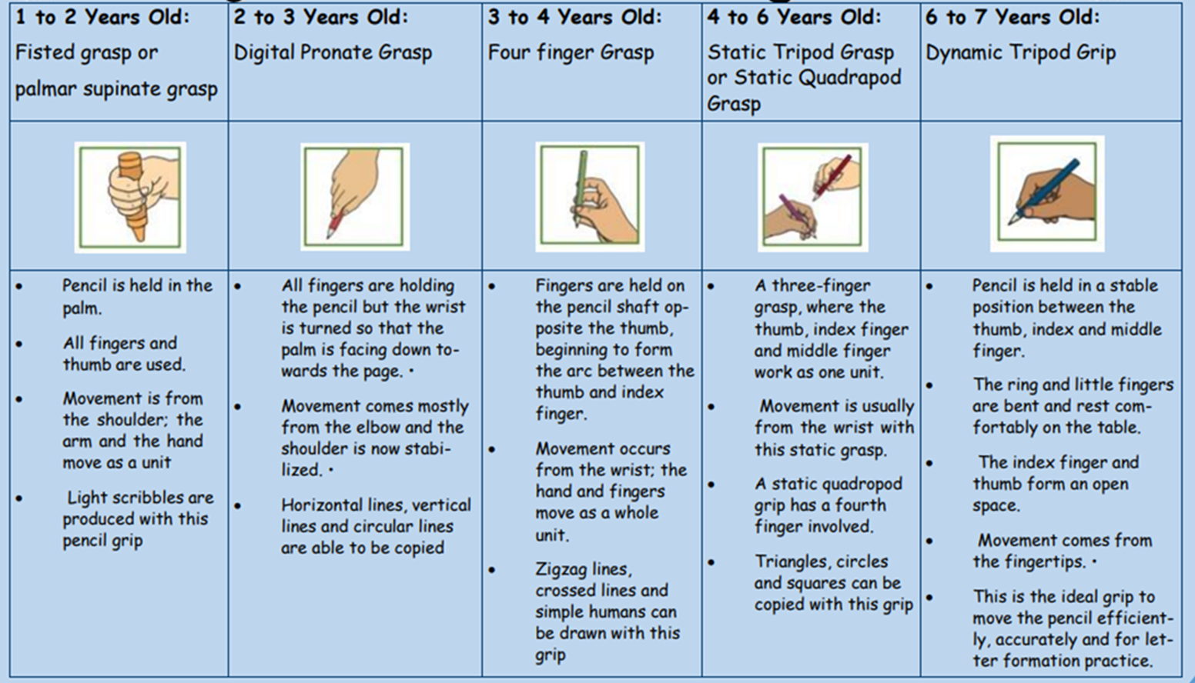

Literacy
EYFS Statutory Educational Programme
It is crucial for children to develop a life-long love of reading. Reading consists of two dimensions: language comprehension and word reading. Language comprehension (necessary for both reading and writing) starts from birth. It only develops when adults talk with children about the world around them and the books (stories and non-fiction) they read with them, and enjoy rhymes, poems and songs together. Skilled word reading, taught later, involves both the speedy working out of the pronunciation of unfamiliar printed words (decoding) and the speedy recognition of familiar printed words. Writing involves transcription (spelling and handwriting) and composition (articulating ideas and structuring them in speech, before writing).

ELG: Comprehension  Children at the expected level of development will:  • Demonstrate understanding of what has been read to them by retelling stories and narratives using their own words and recently introduced vocabulary. • Anticipate – where appropriate – key events in stories.  • Use and understand recently introduced vocabulary during discussions about stories, non-fiction, rhymes and poems and during role-play. | ELG: Word Reading  Children at the expected level of development will:  • Say a sound for each letter in the alphabet and at least 10 digraphs.  • Read words consistent with their phonic knowledge by sound-blending.  • Read aloud simple sentences and books that are consistent with their phonic knowledge, including some common exception words. | ELG: Writing Children at the expected level of development will:  • Write recognisable letters, most of which are correctly formed.  • Spell words by identifying sounds in them and representing the sounds with a letter or letters.  • Write simple phrases and sentences that can be read by others.
- Print-rich environment with labelled resources, displays and accessible books indoors and outdoors.
- Daily story time to develop listening, comprehension and enjoyment of books.
- Phonics and sound awareness through rhymes, songs and sound games.
- Mark-making opportunities across all areas of provision using a variety of materials (chalk, pencils, paint, clipboards).
- Fine motor activities such as playdough, threading, cutting and tweezers to strengthen early writing skills.
- Role play areas encourage purposeful reading and writing (menus, lists, tickets, signs).
- Adults model reading and writing for real purposes such as labels, captions and recording children’s ideas.
- Small group literacy opportunities support phonics, letter recognition and name writing.
- Children retell stories using puppets, props, small world and role play.
- Families are encouraged to share books and stories at home.
Overview
The programme supports early literacy through high-quality stories and picture books, discussion about characters, events and emotions, developing listening and comprehension skills, and opportunities for mark making, drawing and early writing.
National Education Nature Park Programme - Supports vocabulary, storytelling and mark making inspired by nature.

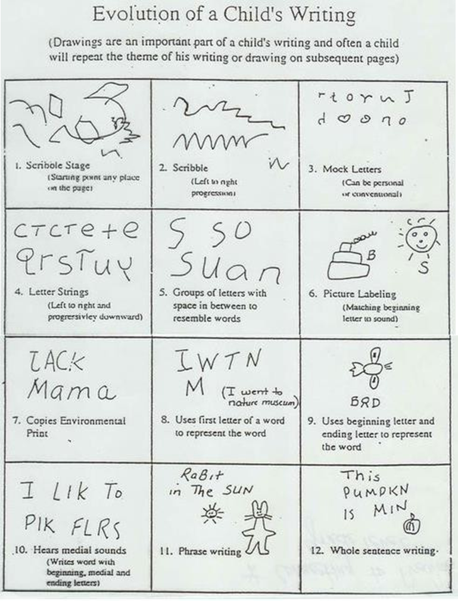

Mathematics
EYFS Statutory Educational Programme
Developing a strong grounding in number is essential so that all children develop the necessary building blocks to excel mathematically. Children should be able to count confidently, develop a deep understanding of the numbers to 10, the relationships between them and the patterns within those numbers. By providing frequent and varied opportunities to build and apply this understanding - such as using manipulatives, including small pebbles and tens frames for organising counting - children will develop a secure base of knowledge and vocabulary from which mastery of mathematics is built. In addition, it is important that the curriculum includes rich opportunities for children to develop their spatial reasoning skills across all areas of mathematics including shape, space and measures. It is important that children develop positive attitudes and interests in mathematics, look for patterns and relationships, spot connections, ‘have a go’, talk to adults and peers about what they notice and not be afraid to make mistakes.
ELG: Number Children at the expected level of development will:  • Have a deep understanding of numbers to 10, including the composition of each number.  • Subitise (recognise quantities without counting) up to 5.  • Automatically recall (without reference to rhymes, counting or other aids) number bonds up to 5 (including subtraction facts) and some number bonds to 10, including double facts. | ELG: Numerical Patterns  Children at the expected level of development will:  • Verbally count beyond 20, recognising the pattern of the counting system.  • Compare quantities up to 10 in different contexts, recognising when one quantity is greater than, less than or the same as the other quantity.  • Explore and represent patterns within numbers up to 10, including evens and odds, double facts and how quantities can be distributed equally.
- Mathematical language is modelled throughout the day during play and routines.
- Counting opportunities during everyday activities such as snack time, lining up and tidying resources.
- Children explore number through songs, rhymes and counting games.
- Continuous provision includes resources such as blocks, puzzles, number lines and sorting objects.
- Practitioners encourage children to compare quantities, sizes and shapes during play.
- Mathematics is embedded in construction, water play, sand play and outdoor activities.
- Children explore patterns, sequencing and matching through practical activities.
- Small group sessions introduce key mathematical concepts such as number recognition and simple problem solving.
- Adults support children in using mathematical vocabulary such as more, less, bigger, smaller and full.
Think Equal supports mathematical development by encouraging children to identify similarities and differences, use language linked to comparison and fairness, develop problem-solving skills in everyday social situations, and engage in early sorting and grouping through emotional themes.
National Education Nature Park Programme - Supports counting, measuring, pattern and observation in natural contexts.

Understanding the World
EYFS Statutory Educational Programme
Understanding the world involves guiding children to make sense of their physical world and their community. The frequency and range of children’s personal experiences increase their knowledge and sense of the world around them – from visiting parks, libraries and museums to meeting important members of society such as police officers, nurses and firefighters. In addition, listening to a broad selection of stories, non-fiction, rhymes and poems will foster their understanding of our culturally, socially, technologically and ecologically diverse world. As well as building important knowledge, this extends their familiarity with words that support understanding across domains. Enriching and widening children’s vocabulary will support later reading comprehension.
ELG: Past and Present  Children at the expected level of development will:  • Talk about the lives of the people around them and their roles in society. 14  • Know some similarities and differences between things in the past and now, drawing on their experiences and what has been read in class.  • Understand the past through settings, characters and events encountered in books read in class and storytelling. | ELG: People, Culture and Communities  Children at the expected level of development will:  • Describe their immediate environment using knowledge from observation, discussion, stories, non-fiction texts and maps.  • Know some similarities and differences between different religious and cultural communities in this country, drawing on their experiences and what has been read in class.  • Explain some similarities and differences between life in this country and life in other countries, drawing on knowledge from stories, non-fiction texts and – when appropriate – maps. | ELG: The Natural World  Children at the expected level of development will:  • Explore the natural world around them, making observations and drawing pictures of animals and plants.  • Know some similarities and differences between the natural world around them and contrasting environments, drawing on their experiences and what has been read in class.  • Understand some important processes and changes in the natural world around them, including the seasons and changing states of matter.
- Children explore the natural world through outdoor learning and seasonal observations.
- Practitioners encourage curiosity, questioning and exploration.
- Children learn about their families, communities and cultures through discussion and activities.
- Resources and books reflect diversity and different ways of life.
- Children investigate materials, objects and simple scientific concepts through play.
- Technology such as tablets, cameras or programmable toys are used appropriately to support learning.
- Visitors, celebrations and experiences help children understand the wider world.
- Children observe changes over time such as weather, plants growing or life cycles.
The Think Equal programme supports children’s understanding of the world by exploring diversity, inclusion and equality, learning about different families, cultures and experiences, encouraging respect for similarities and differences, and helping children understand how actions impact others.
National Education Nature Park Programme - Develops understanding of the natural world, seasons, sustainability and environmental care.

Expressive Arts and Design
EYFS Statutory Educational Programme
The development of children’s artistic and cultural awareness supports their imagination and creativity. It is important that children have regular opportunities to engage with the arts, enabling them to explore and play with a wide range of media and materials. The quality and variety of what children see, hear and participate in is crucial for developing their understanding, self-expression, vocabulary and ability to communicate through the arts. The frequency, repetition and depth of their experiences are fundamental to their progress in interpreting and appreciating what they hear, respond to and observe.
ELG: Creating with Materials Children at the expected level of development will:  • Safely use and explore a variety of materials, tools and techniques, experimenting with colour, design, texture, form and function.  • Share their creations, explaining the process they have used.  • Make use of props and materials when role playing characters in narratives and stories. | ELG: Being Imaginative and Expressive Children at the expected level of development will: 15  • Invent, adapt and recount narratives and stories with peers and their teacher.  • Sing a range of well-known nursery rhymes and songs.  • Perform songs, rhymes, poems and stories with others, and – when appropriate – try to move in time with music.
- Children have daily access to creative resources such as paint, collage materials, clay and drawing tools.
- Open-ended materials encourage imagination and creativity.
- Music, singing and rhymes are used regularly throughout the day.
- Children explore instruments, rhythm and movement.
- Role play and small world areas encourage storytelling and imaginative play.
- Children experiment with colour, texture and different art techniques.
- Dance and movement activities allow children to express themselves physically.
- Adults encourage children to talk about their creations and creative choices.
- Children are supported to develop confidence in expressing ideas and feelings through art, music and play.
Think Equal encourages creative expression through role play and imaginative play, art activities to express feelings, music and movement to explore emotions, and opportunities for children to communicate experiences creatively.
National Education Nature Park Programme- Inspires creativity using natural materials, music, movement and imaginative play.

Impact
Through the Think Equal programme, preschool children develop emotional literacy, positive relationships and a strong sense of self. This supports children to feel safe, valued and confident, enabling them to engage positively in learning and prepare for the next stage of their education.

British Values Mapping – Preschool - Aligned with EYFS, Think Equal and National Education Nature Park
British Value | What this looks like in our Preschool | Links to Curriculum
Democracy | Children are encouraged to make choices, share opinions, take turns and be listened to during play and group times. | Think Equal discussions, child-led play, circle time, independence and voice.
Rule of Law | Children learn clear expectations, routines and boundaries to help them feel safe and secure. | Positive behaviour modelling, Think Equal emotional regulation, consistent routines.
Individual Liberty | Children are supported to make choices, develop independence and express their feelings safely. | Think Equal emotional literacy, independence, child choice, outdoor learning.
Mutual Respect | Children are taught to respect others, listen to different viewpoints and value everyone. | Think Equal inclusion, respect value, diverse stories and experiences.
Tolerance of those with different faiths and beliefs | Children learn about similarities and differences, families and communities in a positive way. | Think Equal diversity focus, Understanding the World, inclusive practice.

